2021 Xmas 5-Days Orienteering
Southern Highlands, December 27-31
Covid-19
The event will be run following strict covid guidelines which will be included on the 5 Days web site, also in the event program and links will also emailed to all competitors immediately prior to the event.
Travel restrictions and border controls, are fluid. Prior to travelling to the event and particularly prior to entering NSW, you should check the latest NSW Public Health Orders.

"Safety provisions will also apply in the event of extreme temperatures and/or bushfires, possibly including alternate venues or cancellations."

Water may be provided on courses at the discretion of the controller for that day. This will be advertised for that day.
Competitors are strongly advised to bring their own water and to carry water on their courses.

Venues

Date | First Start | Event | Map | Club | Event Link
Mon Dec 27 | 4pm | Bush sprint | Welby | SHOO | Day 1
Tues Dec 28 | 8am | Long | Belanglo SF | IKO | Day 2
Wed Dec 29 | 8am | Middle | Penrose SF | Stingers | Day 3
Thurs Dec 30 | 8am | Middle | Wattle Ridge (updated) | BN | Day 4
Fri Dec 31 | 8am | Sprint | St Gregory’s College (new) | SHOO | Day 5

Format
Best 4 of 5 results to count.
Event Information
The 5-days program will be available through the Eventor Entry Portal from Tue Dec 14th.
See also the Xmas 5-Days web page.
Start Times
Walk up starts within a set start window for each day will be used. 1 minute start intervals
Entry Fees (Per Day):
Members: Senior $25, Junior $16, Sub-junior $12.50

Casuals/Non-members: add $3

Sport Ident Hire: $4 per day

Entries close: midnight Tuesday December 14th

NO EOD will be available any day due to Covid distancing rules.
Important Entry Information
- If you are intending to run the same class for all 5 days, please enter here via Eventor

- If you are entering individual days or wish to enter different classes on different days, use the daily entry event for each of the days.

If you wish to have your result counted in the overall competition you must enter the same course each day.

Accommodation
Mittagong and nearby towns offers a wide variety of accommodation; visit the Mittagong Tourism website
Goulburn is another option visit the Goulburn Tourism website
Alternate sites for accommodation include AirBnB, Stayz, Booking.com.
NB: Belango House is closed due to Covid Restrictions

Courses/Classes
Course lengths are a guide, as are the suggested age classes.
You choose the distance you want to run each day!

 | Course* | Men Class | Women Class | Suggested age guides
1 | Hard 1 - 7km | Men A |  | M21
2 | Hard 2 - 6km | Men B | Women A | M20,35 | W21
3 | Hard 3 - 5km | Men C | Women B | M16, 45 | W20,35
4 | Hard 4 - 4km | Men D | Women C | M55 | W16,45
5 | Hard 5 - 3km | Men E | Women D | M65+ | W55+
6 | Moderate 3.5km | Men F | Women E
7 | Easy | Men G | Women F
8 | Very Easy | M/W Novice
*Approximate distances only and does not apply to the days 1 and 5.

Event Co-ordinator
Colin Price colinp53@yahoo.com.au Mob. 0415210339
Locality Map (approximate only)
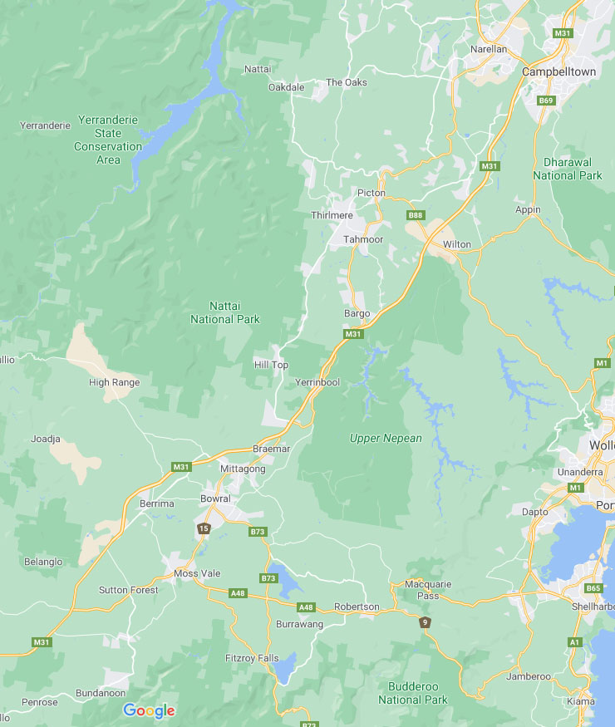
Day 1
Day 2
Day 3
Day 4
Day 5

