ABC

and

Screen Australia

Presents

Fresh Blood 3

Guidelines
April 2023

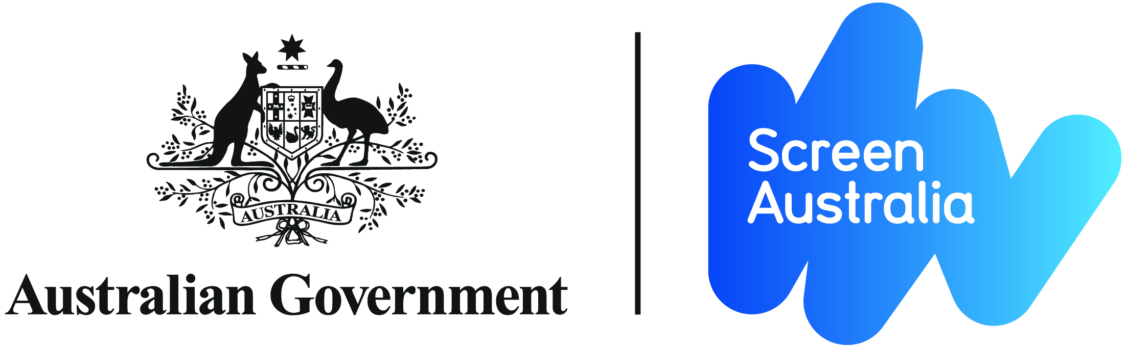

Screen Australia and ABC have partnered in an initiative to support and showcase the best of Australia’s emerging comedy and entertainment content creators and performers.

Fresh Blood 3 aims to fund up to ten individuals and teams to make short comedy and entertainment content, and have it promoted and broadcast under the Fresh Blood brand.

The successful applicants will be supported to make three comedy shorts of 3-5-minutes duration each, in narrative or sketch comedy but designed to appeal to younger audiences (under 40 years). They may be character-driven, animated or vertical video but most important are the fresh ideas, strong comedy, and talented teams.

Once all the shorts are delivered, ABC and Screen Australia will select up to three of the individuals/teams to make a longer pilot between 20-27 minutes in length.

If ABC and Screen Australia agree, there is then scope for a successful pilot to be commissioned by ABC as a series.

The shorts are intended to premiere simultaneously on ABC social media platforms and the creators’ own social media platforms. The pilots will premiere on ABC television and iView.

The initiative has strong industry development goals and aims to provide a career-changing opportunity for new and diverse talent, whether they are handling all roles themselves or working in a team, by showcasing their talent, and by building their development and production skills. Importantly, it also gives the opportunity to work with a key broadcaster.

Australia has one of the most culturally diverse populations in the world. More than one in ten Australians now identify with diverse sexual orientation or gender identity, and just under one in five people report having a disability. For the purpose of these guidelines, diversity encompasses cultural background, disability status, sexual orientation, and identity and First Nations creators.

Creators who submit successful applications will participate in a 1-3 day workshop in August 2023 at ABC in Sydney. The aim of the workshop will be to professionalise your online video work, and work towards a sustainable career. Teams outside of Sydney will receive flights and accommodation for up to three team members to attend the workshop.

The ABC and Screen Australia will appoint a Supervising Producer and Investment Manager, respectively, to the projects.
Successful applicants should be capable of delivering the three shorts to ABC by mid-January 2024.

What funding is available?
Up to 10 applicants will be selected to produce their shorts. Successful applicants will be given up to $50,000 to create 3 shorts of approximately 3-5 minutes duration each.
The completed shorts will premiere simultaneously on ABC social media platforms and the applicants’ social media platforms.

Who can apply?

Are you the next big thing in Aussie comedy? Maybe you make and share your own content online or have a profile as a stand up or sketch comedian. Maybe you already have a fan base and want to create longer content with bigger budgets. Maybe a bit of all of these things.

We’re looking for teams (of at least two people) who can put together a team to write, perform, shoot & edit all of their own material. Teams are encouraged to have the roles of Writer, Director and Producer filled at time of applying, across at least two team members.

Applicants must also:
- Be an Australian citizen or resident
- Where applicable, the applicant company must be incorporated and carrying on business in Australia, and have its central management and control in Australia
- Meet the general eligibility requirements set out in Screen Australia’s Terms of Trade

As this initiative is aimed at emerging creators, if you have more than 30 minutes of commissioned content with a broadcaster or streaming platform you are not eligible to apply.

What materials do you need to submit?

- A completed application form.
- Existing sketch:
- For consideration for commissioning, your application must include an existing video sketch or comedic performance as a sample of your work. This can be a sketch that already exists somewhere online.
- Your application must include a URL link to the online sample existing sketch.
- A proposal document (of not more than 5 pages) providing an overview of your application, including:
- An outline of the 3 episodes/sketches of 3-5 minutes’ duration you would make if your application is successful.
- Details of the cast and how the episodes will be produced, including a brief description of the role of each key team member, and a strategy for coping with all key roles.
- A brief budget detailing how the $50,000 would be spent on production of the three sketches, which should include the number of personnel required, how long it might take, and the resources required. The budget should include a line item for the cost of obtaining independent legal advice. (see Legal below)
- Details of your existing social media profiles and a proposal about how, if you’re successful, you might use the content created for Fresh Blood 3 on your existing social media platforms.
- A short biography of all key creatives involved.
- A personal diversity statement and/or outline how you contribute to diversity in screen content and practice.
- Reference to how the proposal addresses the assessment criteria.
- Any other information that you think is relevant and helpful, including links to any other online work.

What is the application and assessment process?

When: Applications must be submitted by 4pm on Monday 29 May 2023.
How: You must submit your application by uploading it onto the Fresh Blood online submission page at www.abc.net.au/freshblood.
Applications will then be viewed and read by both ABC and Screen Australia. Applicants will be notified about the outcome of their application by email or telephone.
Queries: The ABC is administering the application process. If you have any enquiries regarding this initiative, please contact:

Yale Macgillivray, Executive Producer
Email: Macgillivray.yale@abc.net.au
GPO Box 9994
SYDNEY NSW 2001

Assessment criteria
When assessing applications for this program, Screen Australia and the ABC will use the following criteria:
- The strength, quality and originality of the concept and comedy.
- The potential of the sketch to appeal to its target audience (under 40 year old digital natives). Please note – existing fan bases may be used as evidence of appeal to target audience (please provide details).
- The ability of the individual or team to complete the project in the time frame proposed and within the given budget, as evidenced by the submission.
- The career development benefits of this project for the individual or team, including consideration of diversity.

Legal
The shorts selected for production will enter into a Licence Agreement with the ABC, with rights as summarised below. All talent and creative works including music will need to be cleared for these rights.
Neither the ABC nor Screen Australia will take a share of copyright in your short or pilot.
Rights
ABC
Stage 1:
- Exclusive (other than for creator social media platforms) rights for ABC social media platforms and ABC iView. Content to premiere on ABC and creator social media simultaneously.

LINK to ABC Licence Agreement for Stage 1

Stage 2:
The ABC will require the following minimum rights to be exercised over a 3-year licence period from delivery:
- World premiere;
      - Exclusive free-to-air television rights for 8 runs;
- Unlimited free streaming rights;
- Promotion Rights;
- Non-exclusive website creation rights;
- Option to commission prequel, sequel, remakes and spin offs;
- First and last right to negotiate to acquire exclusive Australian free-to-air television and online rights in prequels, sequels, remakes and spin offs. This right will end if you are not engaged to make a pilot;
- Holdbacks as per the ABC Stage 2 Licence Agreement.

The ABC Licence Agreement for Stage 2 will be provided to producers who proceed to this stage.
For Stage 2, teams are required to submit applications to Screen Australia for 50% of the funding and teams will enter into a separate agreement with Screen Australia.

Screen Australia Rights
In addition to the above, Screen Australia will require some consultation and approval rights, and a free licence to incorporate and publish your materials worldwide for corporate and promotional purposes in accordance with its standard terms of funding.

Stage 3
If you move to Stage 3 you will enter into a standard ABC licence agreement which will include a grant of rights to the ABC in accordance with any then current terms of trade between the ABC and the Screen Producers Association, if applicable, unless otherwise agreed.

Application to Screen Australia will also be required for Stage 3, with the proportion of funding from Screen Australia determined at the relevant time. More information on this process will be supplied to the successful team at the appropriate time.

For all enquiries please contact Yale Macgillivray, Executive Producer, ABC on:
Email: macgillivray.yale@abc.net.au

