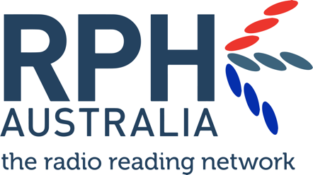

Memorandum of Understanding

This document represents an agreement between
RPH AUSTRALIA CO-OPERATIVE LTD (“RPHA”)
And
(Station name)
(Station address)

commencing
(date 2019)

Introduction
This Agreement aims to develop a mutually beneficial partnership between RPHA and your community radio station. It recognises our shared responsibility to encourage the production of new, diverse, quality, local RPH programming made by and for people with a print disability by supporting the Standards for RPH Programming on Community Radio (PDF, 359KB) (Standards).

Purpose
The purpose of this agreement is to:

- Record the agreement of (station name) to:
  - Discuss the Standards for RPH Programming on Community Radio with RPH program producers as well as relevant staff and volunteers
  - Adhere to all Programming and Community Consultation and Engagement Standards within the Standards for RPH Programming on Community Radio
  - Seek guidance and support from RPH Australia if required
  - Acknowledge the support of RPH Australia on your station website

- Record the agreement of RPHA to maintain the Standards and provide support, resources and information to assist regional community radio stations in producing RPH programming that adheres to those Standards.

Objectives of the RPH Programming Standards
The Standards establish a framework for the production of RPH programming by community radio stations with a non-RPH broadcast licence. They apply to any program produced by these stations, in the name of RPH, to serve people with a print disability.

The Standards aim to encourage new, diverse, quality, local programming made by and for people with a print disability and contain:
- Programming Standards – criteria outlining what RPH programs should contain and how programs should be produced and broadcast
- Community consultation and engagement Standards – criteria to ensure RPH programs are relevant and accessible, to best serve people with a print disability

About this MoU
Completing this MoU and adhering to the Standards is a condition of:
- accessing Community Broadcasting Foundation (CBF) funding for RPH programming
- participating in RPH Australia’s National Sponsorship Scheme

Regional community stations (outside the broadcast 'footprint' of an RPH licensed radio service) can apply for CBF Content funding to support local RPH programming. As part of that grant application, stations must complete this MoU. Stations producing RPH programming are also invited to participate in government sponsorship campaigns via RPHA’s National Sponsorship Scheme.

This document is a statement of understanding and is not intended to create legal obligations on either party.

Term of this MoU
This MoU commences on the date appearing below and remains in place for one year unless the parties agree to vary or terminate it.

About RPH Australia
RPH Australia is the peak body for the Radio Reading Network, a national Co-operative of community radio services dedicated to providing access to information for the estimated 5 million Australians with a print disability. We champion the rights of all people to access printed material, empowering equal participation in cultural, political and social life.

Contact us
If you have any questions or feedback, please contact us:

RPH Australia Co-operative Ltd.
Peak body for the RPH Radio Reading Network
PO Box 89
South Hobart TAS 7004
Phone: 0417 453 643
Email: admin@rph.org.au
Web: www.rph.org.au
Memorandum of Understanding
This document represents an agreement between
RPH AUSTRALIA CO-OPERATIVE LTD (“RPHA”)
And
(STATION NAME)

RPHA | Station Name
Name: Marilyn Alborough | Name:
Title: Chief Executive Officer | Title: (authorised representative)
Signature: | Signature:
Date: | Date:

